**Άσκηση 1.2, Ερώτημα Δ**

Σχεδιασμός της ισοσταθμικής καμπύλης:

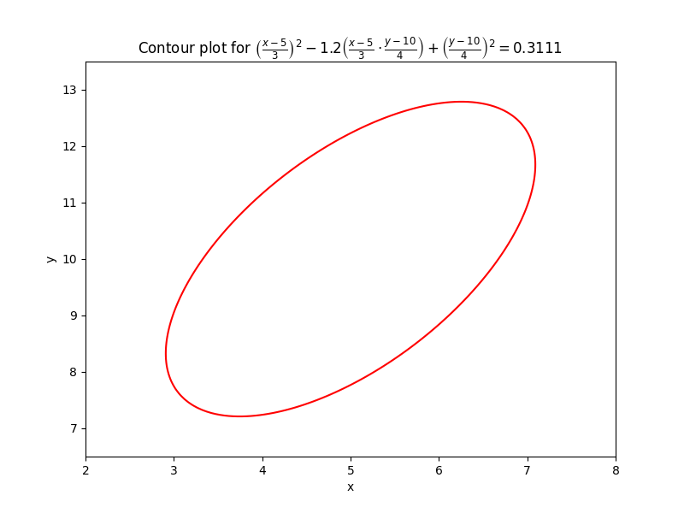

Ο κώδικας που χρησιμοποιήθηκε είναι ο ακόλουθος:

import numpy as np

import matplotlib.pyplot as plt

# Define the function based on the given equation

def contour_function(x, y):

    term1 = ((x - 5) / 3) ** 2

    term2 = -1.2 * ((x - 5) / 3) * ((y - 10) / 5)

    term3 = ((y - 10) / 5) ** 2

    return term1 + term2 + term3

# Set up the grid of x and y values

x = np.linspace(-5, 15, 400)

y = np.linspace(0, 20, 400)

X, Y = np.meshgrid(x, y)

# Calculate Z values on the grid

Z = contour_function(X, Y)

# Define the contour level based on the given constant

contour_level = 0.111111111113

# Plotting

plt.figure(figsize=(8, 6))

contour = plt.contour(X, Y, Z, levels=[contour_level], colors='red')

plt.xlabel('x')

plt.ylabel('y')

plt.title(r'Contour Plot')

plt.xlim([2.5, 7.5])

plt.ylim([7.5,12.5])

plt.show()

Για τα προηγούμενα ερωτήματα οι υπολογισμοί έγιναν με τον ακόλουθο κώδικα

from scipy.stats import norm

from math import sqrt

# (b)

y = 10 # y > 10

mean_y_given_x = 10.8

std_y_given_x = sqrt(10.24)

prob = norm.sf(y, loc=mean_y_given_x, scale=std_y_given_x)

print(f"Probability is : {prob:.4f}")

# (c)

x = 5 # x > 5

mean_y_given_x = 4.55

std_y_given_x = sqrt(5.76)

prob = norm.sf(x, loc=mean_y_given_x, scale=std_y_given_x)

print(f"Probability is : {prob:.4f}")